**INPLANTTRAININGMANUAL**



**INFORMATION TECHNOLOGYDEPARTMENT**

NAME OF STUDENT:-SAHIL MANOHAR RAUT

PROGRAM :- INFORMATION TECHNOLOGY

SEMESTER/YEAR :- 6TH SEMESTER/ 3RD YEAR

ENROLLMENT NO :- FS19IF010

CONTACT NO :- 9136189478

GOVERNMENTPOLYTECHNIC,MUMBAI

(AnAutonomousInstituteofGovernmentofMaharashtra)

49, Ali Yavar Jung Marg, Kherwadi, Bandra (East), Mumbai – 400 051Website:[www.gpmumbai.ac.in](http://www.gpmumbai.ac.in/)



**GOVERNMENTPOLYTECHNIC,MUMBAI**

**VISION:**

Transformknowledgeintowork.

**MISSION:**

Wearecommittedfor

1. Qualityeducationforlifelonglearning
2. Needbasededucationalprogrammesthroughdifferentmodes
3. Outcomebasedcurriculumimplementation
4. Development&upgradationofstandardlaboratorypractices
5. Promotingentrepreneurialprogrammes

Webelieveinequality,safety,environmentfriendlypractices&teaching learning innovations



**INFORMATION TECHNOLOGYDEPARTMENT**

**VISION:**

Develop IT professionals to solve real life problems

**MISSION:**

Information technology department is committed to

* Offer need based quality education for lifelong learning
* Continuous up gradation of curriculum and laboratories through industry institute interaction.
* Conduct short term programmes to serve society.
* Develop entrepreneurial capabilities.
* Imbibe social awareness and responsibility in students to serve the society and protect environment
* Make the students industry ready to enhance their employability in theindustries.

**STUDENTSPERSONALINFORMATION**

* Student’sFullName:- Sahil Manohar Raut

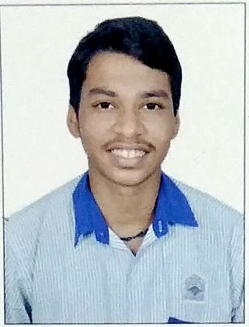

* Programme: Information Technology
* Class/Div:- Third Year First Shift
* BloodGroup: -**B+**

EnrollmentNo.: FS19IF010 DateofBirth:- 05/09/2003

* ContactNo.: 9136189478
* EmergencyContactNo.:- 9769469972
* ResidentialAddress:- Room No.405,Tranzist Camp,Shastri Nagar,
* Pratiksha Nagar,Sion Koliwada,Mumbai-400022
* PermanentAddress: :- Room No.405,Tranzist Camp,Shastri Nagar,.
* Pratiksha Nagar,Sion Koliwada,Mumbai-400022.
* ParentDetails:

1. Father’sName:- Manohar Sakharam Raut

Occupation:- Service EmailId:- manoharraut19@gmail.com

ContactNo.: 9870788604

OfficeAddresswithContactNo.: Traffic Headoffice,2nd Floor,Wadala Depoat,

Tilak Road (Extension),Wadala Mumbai-400031.

1. Mother’sName:Bharati Manohar Raut Occupation:HouseWife ContactNo.: 9152585861 EmailId: NA

OfficeAddresswithContactNo.: NA

Name&Signofthestudent Name&SignofFather/Motherofstudent

**JOINING REPORT**

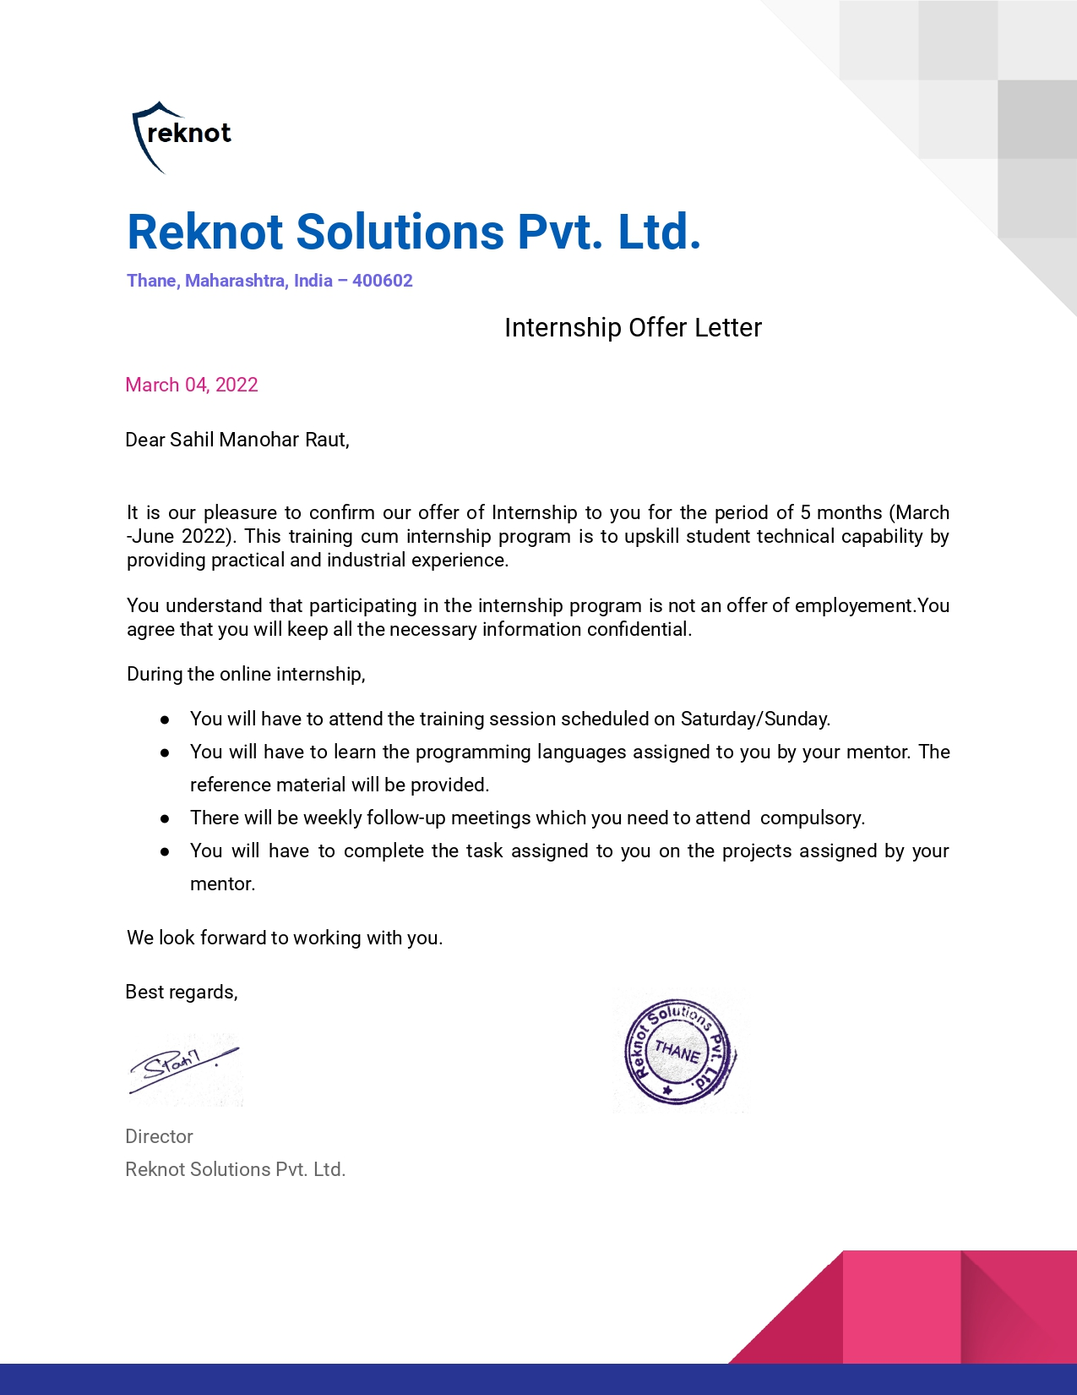

**COMPLETION LETTER**

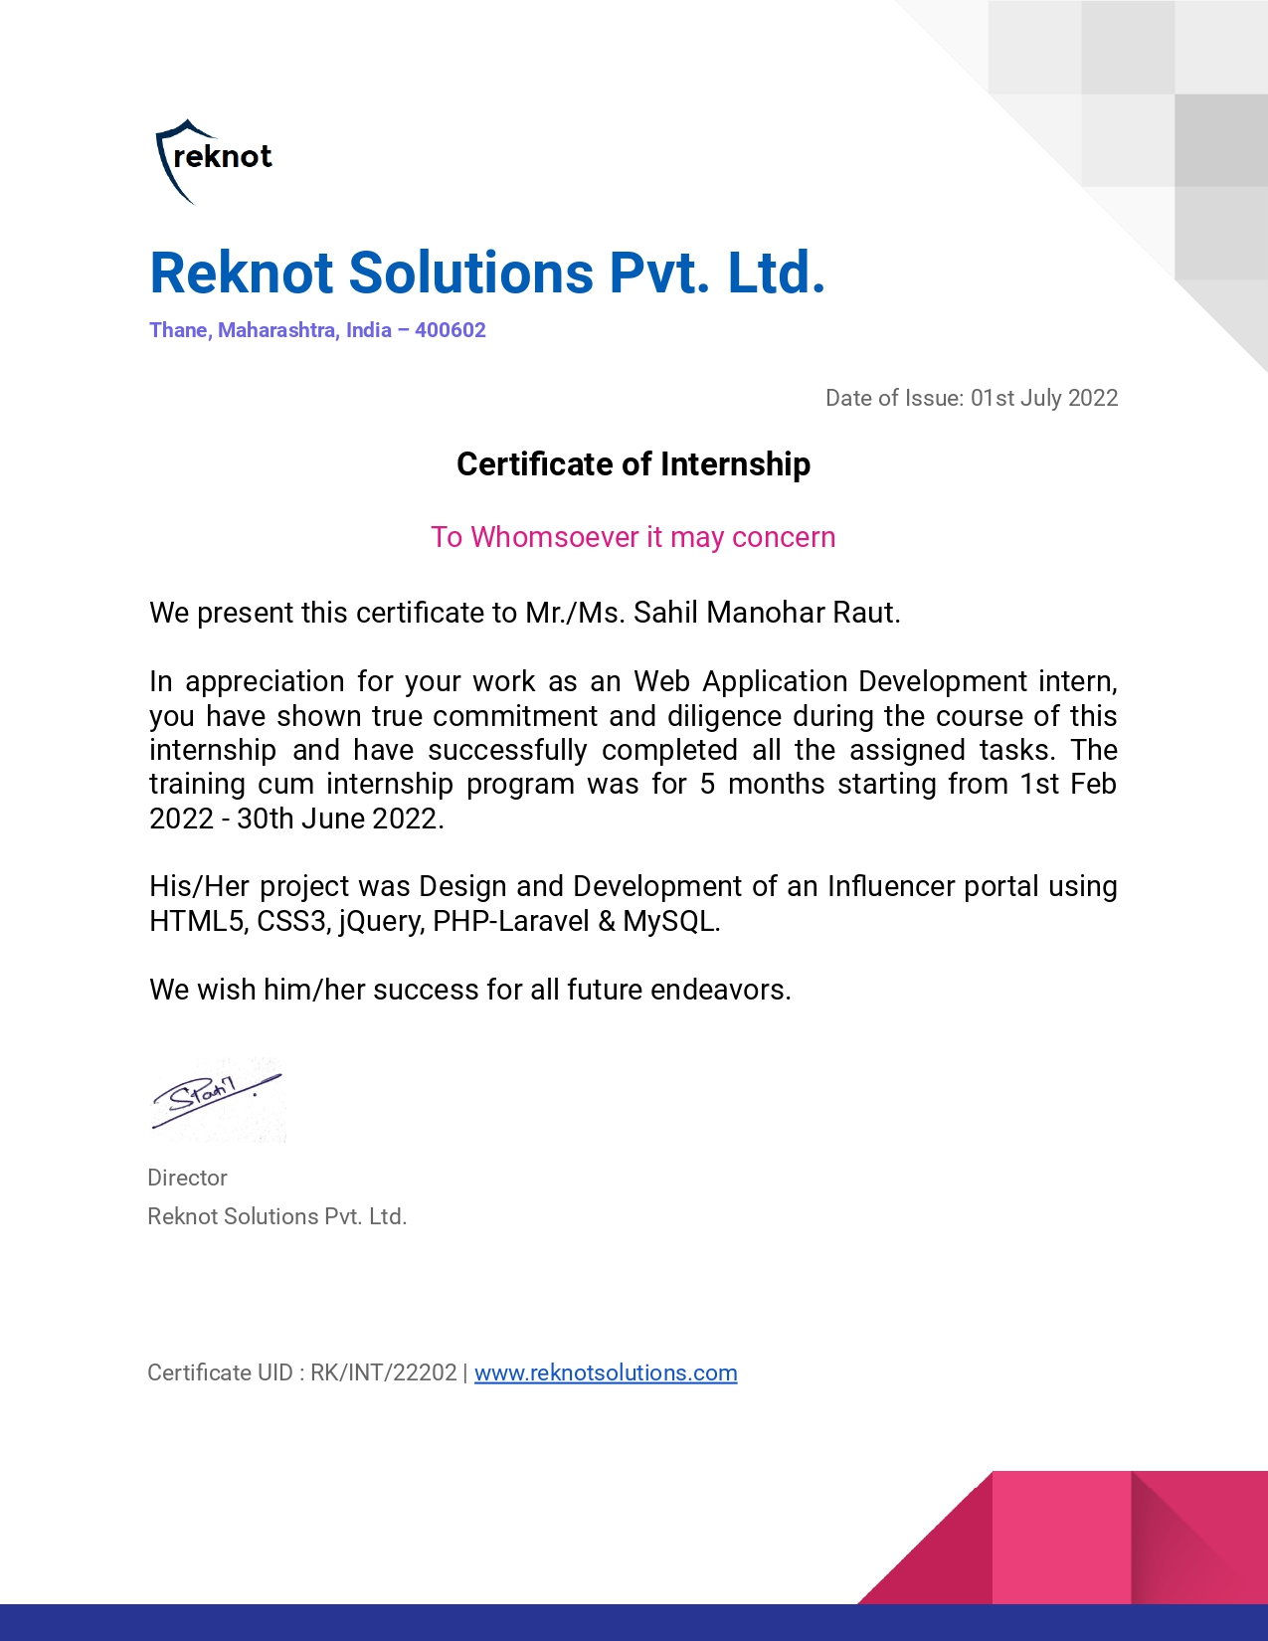

INDEX

1. Introduction of the Industry ……………………………………… 1-2
   1. My Role in Industry/ Introduction to Industry
   2. The Objectives of Industry
2. Organizational structure …………………………………………... 3-5
   1. Organizational Structure
   2. Work Culture
   3. Quality Control
   4. Role of Engineer
3. Learning resources collected …………………………………… 6-11
   1. Learning Resources Collected
   2. Reading Material
   3. Photographs
4. Detail report on work done ……………………………………….12-21
   1. Weekly Report
5. Conclusion ………………………………………………………22-23
6. References………………………………………………………..24-25

**CHAPTER 1**

**INDUSTRY INTRODUCTION**

**Introduction of the Industry:**

• Founded in 2018 and it is a Development & Design expert company providing superior Software, Web, Mobile and Creative Designing solutions and services.

• We strive to provide you with the best solutions to your business system needs. As our client, we place great emphasis and focus on your problems and goals and develop solutions that best fits your needs. We offer strong and effective solutions to your business with an enduring impact. We think of ourselves as your long-term partner.

• As partners, we will ensure your business needs are carefully evaluated and will decide the best methods to represent your company, and develop a strong and effective solution for your business that will have an enduring impact.

• We have succesful experience of 10 + products hand overed to clients and oprerationally performing best in the market.

**Location:**Thane, Maharashtra.

**Technical / Non-technicql Skilled personnel:**Total 12.

**Marketing Strategies:**Word-of-mouth, Email marketing, Customized software services, Cost etc.

**Software Services**: Website Developement, Mobile Application Developement, Web Application Development, UI-UX are major software services.

**Products:**AgriBusiness ,EduTech, Telecom and E-commerece Sector.

**CHAPTER 2**

**Organizational structure**

# OrganizationalStructure:

Director/s

Manager(MobileApp)

Manager(Design)

Manager(WebApp)

WebAppDeveloper

UXDesigner

**Workculture:**

MobileDeveloper

* Wekeepitshortandsimple
* Respectandfairness
* Trustandintegrity
* Growthmindset
* Teamwork
* Employeeengagementandopportunitiesforadvancement
* Communicationandtransparency
* Results
* Work-lifebalance
* Impacton theworld

# QualityControl:

* FollowsQualityAssurance (QA),QualityControl(QC)andTesting
* UnitTesting->Integrationtesting->SystemTesting->SecurityTesting->UAT
* CoversentireSDLC
* Continousmonitoring
* ApplyFitforPurpose

# RoleofEngineer:

**AndroidApplication Developer:**

* Building and Designing advancedAndroidapplicationsforAndroidplatform
* Cross-functionalteamcollaborationtodesign,defineandshipnewfeatures
* TouseandworkwithoutsideAPIsanddatasources
* Toperformunittesttoensureusability,robustness,edgecasesandgeneralreliability
* Toworkandmakesureimprovedapplicationperformanceandbugfixing
* Continuousevaluation,discoveryandimplementationofnewtechnologiestomaximizetheefficiency of development.

**BackEndDeveloper**:

* Storingdataandalsoensuringthatitisdisplayedtothatuserwhoaresupposedtohaveaccessto it
* ResponsiblefordevelopingPaymentprocessingsystemlikeacceptingdata,securelystoringthatinfo,and makingcharges tothatpayment
* ManageAPIsresourceswhichworkacrossdevices
* Heorshemightbeinvolvedinthearchitectureofasystem andData scienceanalyses.
* Developersareresponsibletoorganizethelogicofthesystemwhichrunsacrossvariousdevices
* Backenddeveloperalsoneedstoinvolvedinbuildingframeworksorthearchitecturetomakeiteasierto programagainst.
* BackEndwebdevelopershouldhavetheskillsforimplementingalgorithmsandsolvingsystem relatedproblems.

**CHAPTER 3**

**LEARNING RESOURCES**

**Learning Resources:**

1. **Laravel**

Laravel is an open-source PHP framework, which is robust and easy to understand. It follows a model-view-controller design pattern. Laravel reuses the existing components of different frameworks which helps in creating a web application.

1. **AdminLte**

AdminLTE is **a popular open source WebApp template for admin dashboards and control panels**. It is a responsive HTML template that is based on the CSS framework Bootstrap 3.

1. **MySQL**

MySQL is an open-source relational database management system. As with other relational manipulate, control, and query data using Structured Query Language, more commonly known

as [SQL](https://www.digitalocean.com/community/tutorials/what-is-sql).

1. **Bootstrap**

**Bootstrap** is the most popular **CSS Framework** for developing responsive and mobile-first websites. **Bootstrap 5** is the newest version of Bootstrap.

1. **PHP**

PHP is a server side scripting language that is embedded in HTML. It is used to manage dynamic content, databases, session tracking, even build entire e-commerce sites.

**Used Software For Development:**

1. **VsCode**

PHP is a server side scripting language that is embedded in HTML. It is used to manage dynamic content, databases, session tracking, even build entire e-commerce sites.

1. **Xampp**

XAMPP is one of the widely used cross-platform web servers, which helps developers to create and test their programs on a local webserver. It was developed by the **Apache Friends**,

1. **PhpMyAdmin**

PhpMyAdmin is a free software tool written in [PHP](https://php.net/), intended to handle the administration of [MySQL](https://www.mysql.com/) over the Web.

**Reading Materials:**

1. [Laravel Documentation](https://laravel.com/docs/8.x)
2. [AdminLte Doc](https://adminlte.io/docs/)
3. Youtube, Google, etc.

**Photographs:**

**Github:**

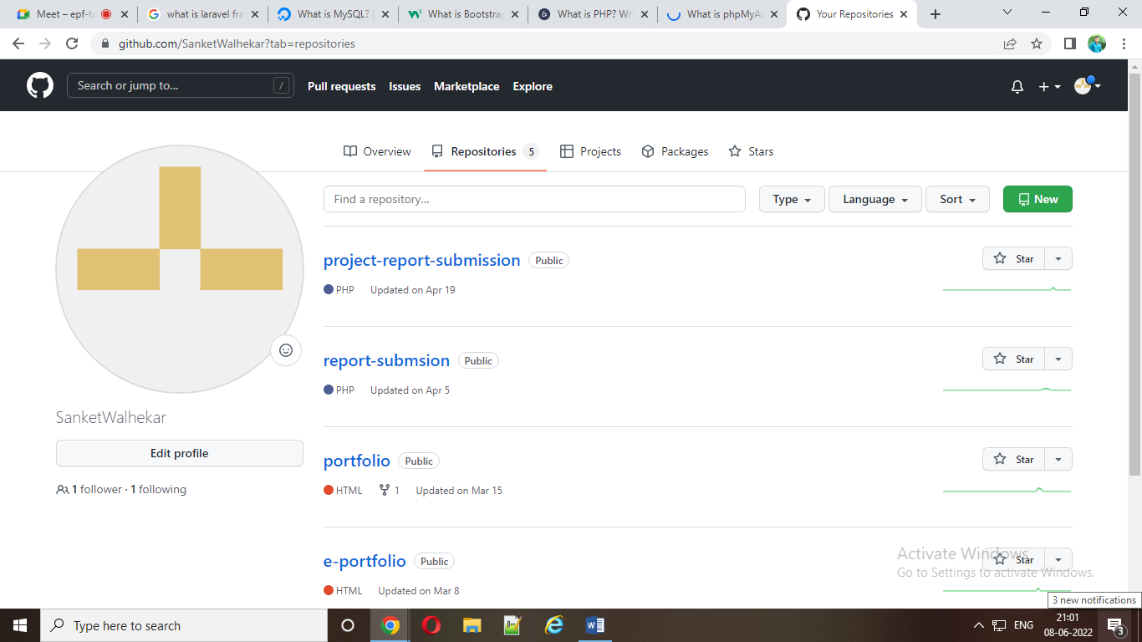

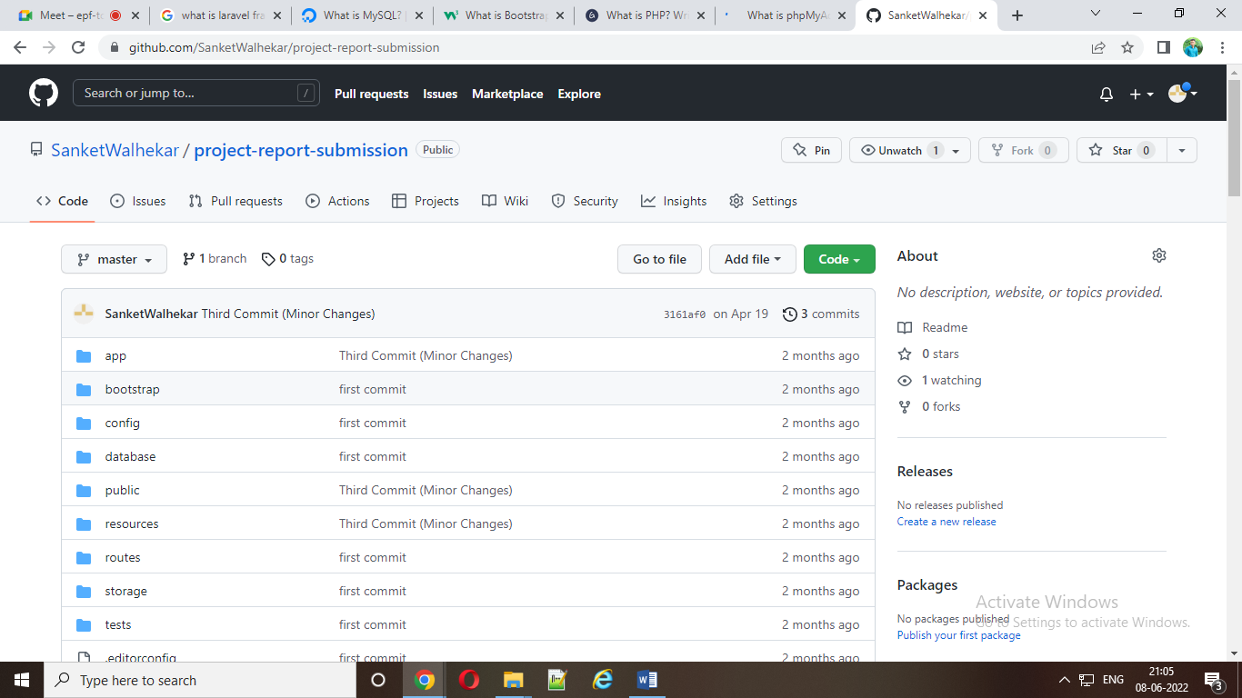

**LaravelTutorial :**

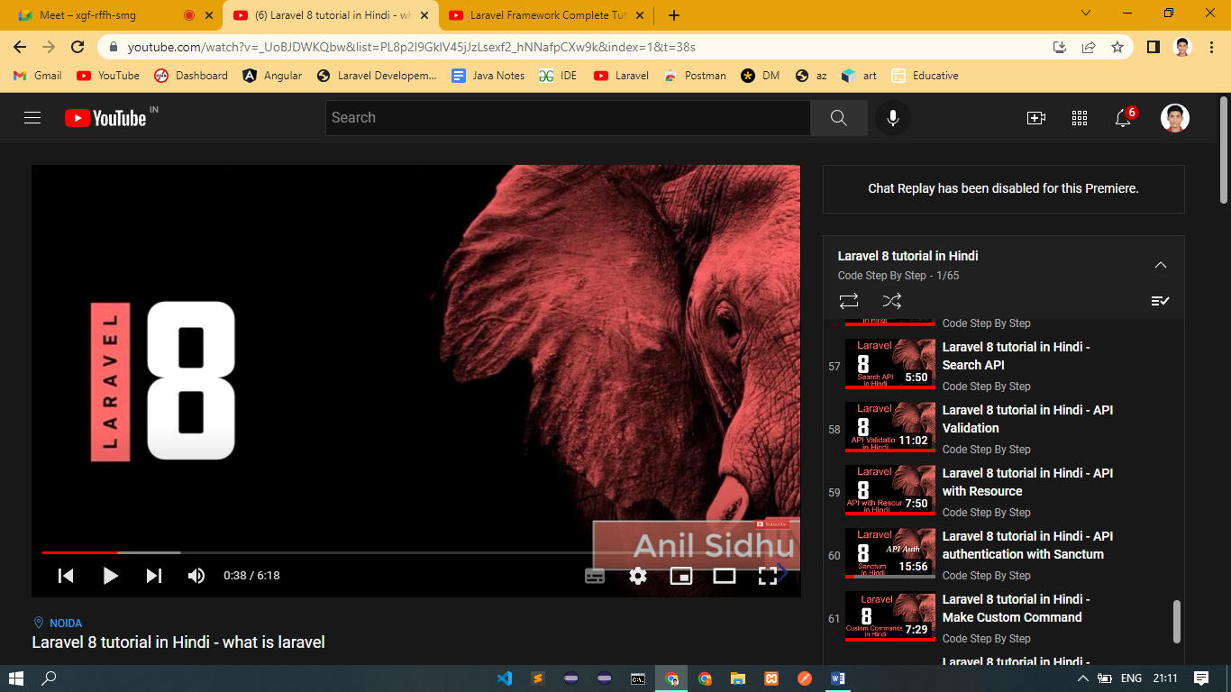

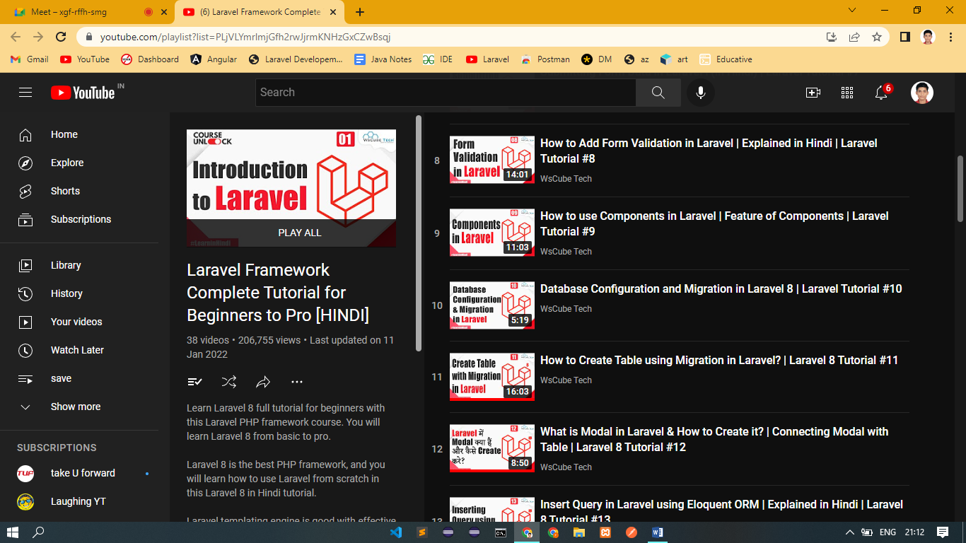

**Bootstrap Tutorial:**

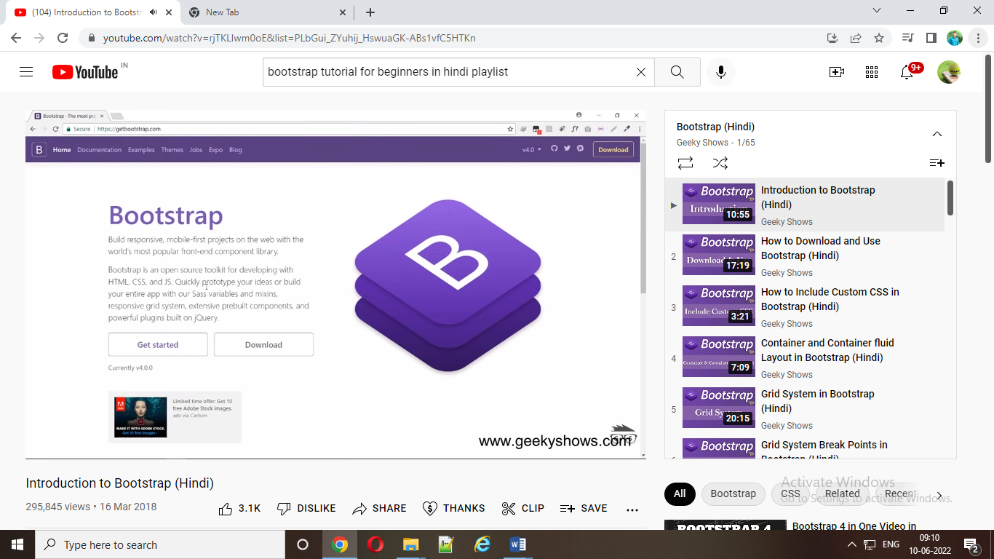

**Xampp Installation Tutorial:**

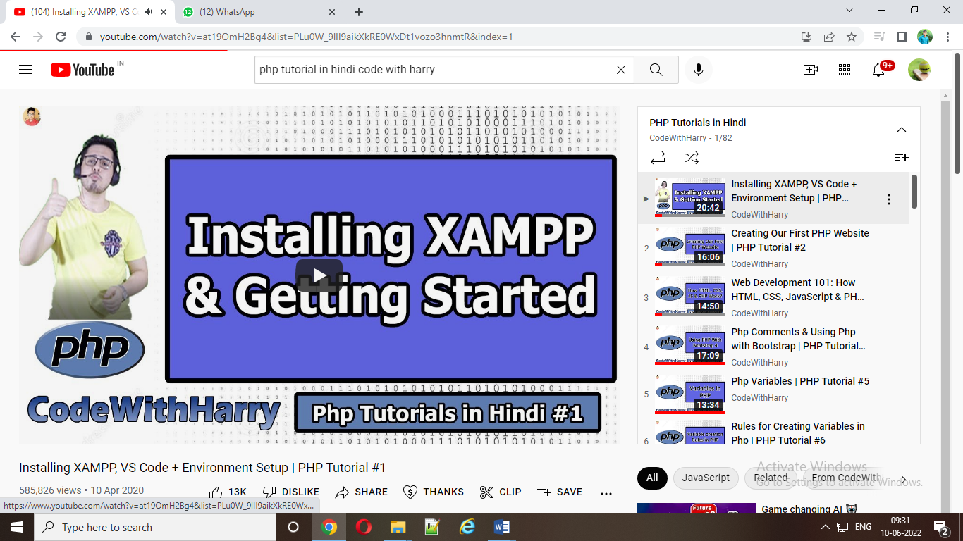

**Adminlte Installation Tutorial:**

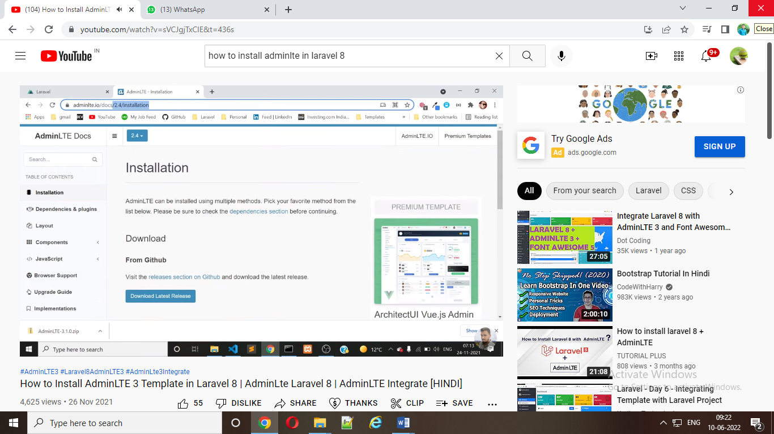

**CHAPTER 4**

**WEEKLY TASK AND ASSIGNMENT**

GOVERNMENTPOLYTECHNIC,MUMBAI

49,Kherwadi,AliYawarJungMarg, Bandra (E), Mumbai-51



### WeeklyReportof InplantTraining



Name of the Student :Sahil Manohar Raut. EnrollmentNo:FS19IF010

Programme :Information Technolgy Dept./Plant/Section:

Company name& Address :Reknot Solutions Private Ltd. Thane

|  |  |  |  |  |
| --- | --- | --- | --- | --- |
| **Week**  **No.** | **Date** | | **Briefweeklyreportofthework**  **done/observationmade** | **Attendance**  **No.ofdays** |
| **From** | **To** |
| 1 | 22/02/2022 | 26/02/2022 | * Introduction with company and mentors. * Examples: which technology used by company, how its works, ethics of company, company policies, work culture , previous project etc. | Present =Absent =Leave = |
| 2 | 28/02/2022 | 04/03/2022 | * Revise Object Oriented Programming Concept. * Learning Bootstrap (CSS Framework). * Learning PHP (Server Scripting Language). | Present =Absent =Leave = |

StudentsSignature:

DatedSignatureofIndustryMentor Dated Signature of PolytechnicMentor

GOVERNMENTPOLYTECHNIC,MUMBAI

49,Kherwadi,AliYawarJungMarg, Bandra (E), Mumbai-51



### WeeklyReportof InplantTraining



Name of the Student :Sahil Manohar Raut. EnrollmentNo:FS19IF010 Programme :Information Technolgy Dept./Plant/Section:

Company name& Address :Reknot Solutions Private Ltd. Thane

|  |  |  |  |  |
| --- | --- | --- | --- | --- |
| **Week**  **No.** | **Date** | | **Briefweeklyreportofthework**  **done/observationmade** | **Attendance**  **No.ofdays** |
| **From** | **To** |
| 3 | 07/03/2022 | 11/03/2022 | * IntroductionAboutGit and Github (Sessions by Mentors). * How Git and Github Used in Industry , and Installation Process of Git and github. * How to configure Git with Visual Studio code . * Practicing Github by creating a Repositories and pushing repositories on Github. | Present =Absent =Leave = |
| 4 | 14/03/2022 | 18/03/2022 | * Revise the Basic Concept of CSS3 and HTML5 * Create a single page Digital e-profile using HTML5 / CSS3 and Bootstrap framework. * That e-Profile contains the personal information , educational Details etc. | Present =Absent =Leave = |

StudentsSignature:

DatedSignatureofIndustryMentor Dated Signature of Polytechnic Mentor

GOVERNMENTPOLYTECHNIC,MUMBAI

49,Kherwadi,AliYawarJungMarg, Bandra (E), Mumbai-51



### WeeklyReportof InplantTraining



Name of the Student :Sahil Manohar Raut. EnrollmentNo:FS19IF010

Programme :Information Technolgy Dept./Plant/Section:

Company name& Address :Reknot Solutions Private Ltd. Thane

|  |  |  |  |  |
| --- | --- | --- | --- | --- |
| **Week**  **No.** | **Date** | | **Briefweeklyreportofthework**  **done/observationmade** | **Attendance**  **No.ofdays** |
| **From** | **To** |
| 5 | 21/03/2022 | 25/03/2022 | * Some UI and other changes in PorfolioGiven by Mentors. * Upload Portfolio on github. * https://github.com/SanketWalhekar/portfolio.git | Present =Absent =Leave = |
| 6 | 28/03/2022 | 01/04/2022 | * Team Formation And Basic Task Allocation to team. * Create the Project report submission form using PHP and Bootstrap. | Present =Absent =Leave = |

StudentsSignature:

DatedSignatureofIndustryMentor Dated Signature of Polytechnic Mentor

GOVERNMENTPOLYTECHNIC,MUMBAI

49,Kherwadi,AliYawarJungMarg, Bandra (E), Mumbai-51



### WeeklyReportof InplantTraining



Name of the Student :Sahil Manohar Raut. EnrollmentNo:FS19IF010

Programme :Information Technolgy Dept./Plant/Section:

Company name& Address :Reknot Solutions Private Ltd. Thane

|  |  |  |  |  |
| --- | --- | --- | --- | --- |
| **Week**  **No.** | **Date** | | **Briefweeklyreportofthework**  **done/observationmade** | **Attendance**  **No.ofdays** |
| **From** | **To** |
| 7 | 04/04/2022 | 08/04/2022 | * Insertionof Form data In Database using Mysql . * View all the submit data in separate page   Using PHP and Bootstrap and MySQL. | Present =Absent =Leave = |
| 8 | 11/04/2022 | 13/04/2022 | * Some Extra Changes in previous task by mentors. * Example: Validation in fields of form. * UI Changes. * Upload the task in Github. * https://github.com/SanketWalhekar/report-submsion.git | Present =Absent =Leave = |

StudentsSignature:

DatedSignatureofIndustryMentor Dated Signature of PolytechnicMentor

GOVERNMENTPOLYTECHNIC,MUMBAI

49,Kherwadi,AliYawarJungMarg, Bandra (E), Mumbai-51



### WeeklyReportof InplantTraining



Name of the Student :Sahil Manohar Raut. EnrollmentNo:FS19IF010

Programme :Information Technolgy Dept./Plant/Section:

Company name& Address :Reknot Solutions Private Ltd. Thane

|  |  |  |  |  |
| --- | --- | --- | --- | --- |
| **Week**  **No.** | **Date** | | **Briefweeklyreportofthework**  **done/observationmade** | **Attendance**  **No.ofdays** |
| **From** | **To** |
| 9 | 18/04/2022 | 22/04/2022 | * Introduction to Laravel Framework. ( By Mentors) * Installation Process of Laravel. * Learning Basic of Laravel. | Present =Absent =Leave = |
| 10 | 25/04/2022 | 29/04/2022 | * Learn How To Create New Project in Laravel , How Create a Controller, Used Of Controller, How To creates Routes, Used of Routes Etc. * Learn the Folder and File Structure Of Laravel . * Practice the Laravel Coding | Present =Absent =Leave = |

StudentsSignature:

DatedSignatureofIndustryMentor Dated Signature of PolytechnicMentor

GOVERNMENTPOLYTECHNIC,MUMBAI

49,Kherwadi,AliYawarJungMarg, Bandra (E), Mumbai-51



### WeeklyReportof InplantTraining



Name of the Student :Sahil Manohar Raut. EnrollmentNo:FS19IF010

Programme :Information Technolgy Dept./Plant/Section:

Company name& Address :Reknot Solutions Private Ltd. Thane

|  |  |  |  |  |
| --- | --- | --- | --- | --- |
| **Week**  **No.** | **Date** | | **Briefweeklyreportofthework**  **done/observationmade** | **Attendance**  **No.ofdays** |
| **From** | **To** |
| 11 | 02/05/2022 | 06/05/2022 | * Some Basic Task Given By Mentors using Laravel Framework * Create the same Project Report Submission Form and View all the Submit Data in separate Page Using Laravel * And Learning Laravel Side by side. | Present =Absent =Leave = |
| 12 | 09/05/2022 | 13/05/2022 | * Learning Laravel. Database Connectivity * How To Connect Database Using Model * How to Save Data in Database,   Delete data in Databae , update data in databae.   * Same task doing in this week. | Present =Absent =Leave = |

StudentsSignature:

DatedSignatureofIndustryMentor Dated Signature of PolytechnicMentor

GOVERNMENTPOLYTECHNIC,MUMBAI

49,Kherwadi,AliYawarJungMarg, Bandra (E), Mumbai-51



### WeeklyReportof InplantTraining



Name of the Student :Sahil Manohar Raut. EnrollmentNo:FS19IF010

Programme :Information Technolgy Dept./Plant/Section:

Company name& Address :Reknot Solutions Private Ltd. Thane

|  |  |  |  |  |
| --- | --- | --- | --- | --- |
| **Week**  **No.** | **Date** | | **Briefweeklyreportofthework**  **done/observationmade** | **Attendance**  **No.ofdays** |
| **From** | **To** |
| 13 | 17/05/2022 | 20/05/2022 | * Doing Some changes in given Task .Try different layout design practices in bootstrap. * Learn Some Concept.   Of Laravel .  Eg. Middleware , Localization, Pagination , Form Validation.   * Practicing Middleware ,Localization , Pagination etc. | Present =Absent =Leave = |
| 14 | 23/05/2022 | 27/05/2022 | * Submit the Task of Project Report Submission Form using Laravel to Mentors. * Learn Laravel.   Eg. Blade Template ,Aggregate Methods , Migration etc. | Present =Absent =Leave = |

StudentsSignature:

DatedSignatureofIndustryMentor Dated Signature of PolytechnicMentor

GOVERNMENTPOLYTECHNIC,MUMBAI

49,Kherwadi,AliYawarJungMarg, Bandra (E), Mumbai-51



### WeeklyReportof InplantTraining



Name of the Student :Sahil Manohar Raut. EnrollmentNo:FS19IF010

Programme :Information Technolgy Dept./Plant/Section:

Company name& Address :Reknot Solutions Private Ltd. Thane

|  |  |  |  |  |
| --- | --- | --- | --- | --- |
| **Week**  **No.** | **Date** | | **Briefweeklyreportofthework**  **done/observationmade** | **Attendance**  **No.ofdays** |
| **From** | **To** |
| 15 | 30/05/2022 | 03/06/2022 | * Learning About Adminlte Framework. (Advanced Bootstrap Framework). * Introduction About AdminLteFraemwork , How its work. * Installation of AdminLte Framework * Practicing and Explore AdminLte   Framework   * AdminLteAndLaravel Integration. | Present =Absent =Leave = |
| 16 |  |  | * Given the task on Collage Management Project. * Create MySql Queries For Database. (Sructure of database Provided By Mentors). * UI Making For Given Tables   (CRUD Operation In Laravel Using AdmiLte). | Present =Absent =Leave = |

StudentsSignature:

DatedSignatureofIndustryMentor Dated Signature of PolytechnicMentor

GOVERNMENTPOLYTECHNIC,MUMBAI

49,Kherwadi,AliYawarJungMarg, Bandra (E), Mumbai-51



### WeeklyReportof InplantTraining



Name of the Student :Sahil Manohar Raut. EnrollmentNo:FS19IF010

Programme :Information Technolgy Dept./Plant/Section:

Company name& Address :Reknot Solutions Private Ltd. Thane

|  |  |  |  |  |
| --- | --- | --- | --- | --- |
| **Week**  **No.** | **Date** | | **Briefweeklyreportofthework**  **done/observationmade** | **Attendance**  **No.ofdays** |
| **From** | **To** |
| 17 |  |  | * UI making for given tables(CRUD operation) in Laravel using AdminLte. (Processing…..) * Waiting for further instructions…….. | Present =Absent =Leave = |
| 18 |  |  |  | Present =Absent =Leave = |

StudentsSignature:

DatedSignatureofIndustryMentor Dated Signature of PolytechnicMentor

**CHAPTER 5**

**CONCLUSION**

**Conclusion:**

I can claim it's internship that helps me gain experience. Thanks to Reknot Solutions Private Ltd , I gained so much more in-depth knowledge of technical skills and personal skills This internship helped me gather theoretical and practical knowledge about HTML5, CSS, PHP, MYSQL, Bootstrap, Laravel and other technologies. Beforehand I was confident about designing and developing frontend of websites. Now I am also confident and competent in backbends

For those students who are willing to work in web development, there are huge opportunities available. To give them the scope for online work and development of website, most private and public organizations employ web designers. With the rapid emergence of the digital industry, web development professionals ' demand is growing, and in the coming days this has already availed so many job opportunity for newcomers.

My internship company gave me a good scope to learn and discover my potentials. I am very grateful to them. Now I am able to develop web and mobile applications. I was fortunate forgetting the chance to meet the real life software development environment.

**CHAPTER 6**

**REFERENCES**

**ReferancesLinks :**

* <https://www.youtube.com/watch?v=H2dB6Hw23jI&list=PL8p2I9GklV45jJzLsexf2_hNNafpCXw9k&index=24>
* <https://adminlte.io/>
* <https://laravel.com/>
* <https://www.php.net/>
* <https://getbootstrap.com/>
* [Bootstrap 5 tutorial - crash course for beginners in 1.5H](https://www.youtube.com/watch?v=c9B4TPnak1A)
* [Bootstrap Tutorial](https://www.youtube.com/watch?v=gqOEoUR5RHg)
* [Learn Bootstrap in less than 20 minutes - Responsive Website Tutorial](https://www.youtube.com/watch?v=eow125xV5-c)
* https://youtu.be/sVCJgjTxCIE